2.1

- Study penguins - X
- Get up early -
- Have breakfast
- Get out in a boat
- Visit different islands
- Take photos
- Have dinner
- Work in the lab
- Write emails
- Go to bed late
- Relax
- Read a book

2, 4, 7, 11

3 2.1 Listen again.

- In the summer my days are long. I GET UP early and HAVE BREAKFAST.

S + V1 (s, es)

S = Subject > He she it
V1 = Fe’l

I work
We learn
You study
They read

He/She/It works
(bu holatda felga s yoki es qo’shiladi

I, we, you, they > Don’t + do
He,She,It > Doesn’t/ Does not + do

Do + I, we, you, they + do?
Does + he/she/it + learn play?

He has

He/she/it Agar fel ch, ss, s, x, z bilan tugasa (es qo’shiladi)

Har doim ravish to be dan keyin va V dan oldin keladi
To be = am is are

S + always/Never + Verb
I always, come on time

S + amlislare/Don’t/Can’t

2.3
- S
- Iz
- S
- Z

- During the week he ALWAYS gets up early and he usually arrives at a volcano at seven o’cklock (always/ usually)

- His work sometimes be dangerous and he never go alone > be – is / works

- He usually returns to the research center at about 1 ocklock. And he always have launch in the lab > have – has

- On Friday and Saturday nights he usually relax at home. He hardly ever go out with friends and he often go to bed early > relaxes, goes, goes

Wake up – uyqudan uy’gonmoq
Get up – uhlayotgan o’rnidan turmoq
Stand up - turmoq

Go home > go TO home bo’lmaydi
Go to bed > uxlamoq
Go to work/university > go to the bo’lishi mumkin farqi uyerga borib o’qisa the qo’shilmaydi, the qo’shilsa maqsad o’qish bo’lmasa

Have a shower

HOME WORK

2.1 not bookdan
2.2 ni yarimi

10.10.2024
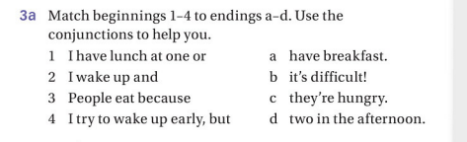

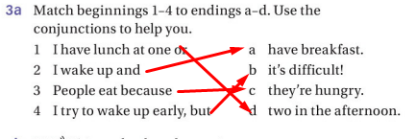

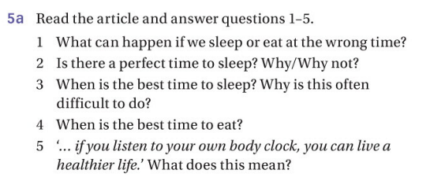

- We will tired and hungry during the day.
- No, because everyone’s body clock is different.
- As Micheal Howell says the best time to sleep is six hours at night and two hours in the afternoon. Difficult? Because most people at work in that best time.
- Best time to eat is two hours after you wake up and three hours before you go sleep.
- Perhabs the most important thing to remember is that

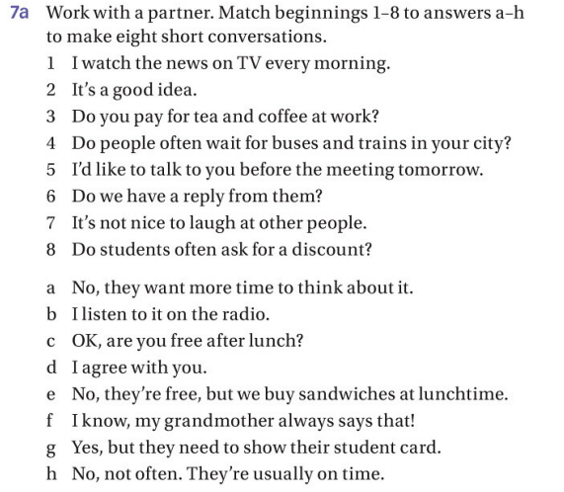
- B
- D
- E
- H
- C
- A
- F
- G

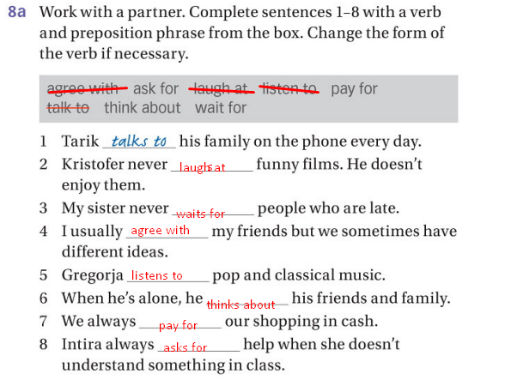

HOME WORK

2.2
2.3

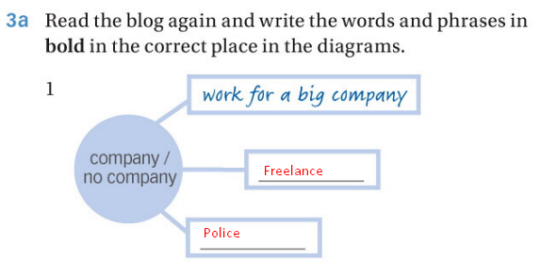
Home work
3.1
1. mechanic.
2. cleaner.
3. An airplane pilot.
4 A photographer.
5 A Student.
6 A musician .
7 A chef or cook.
8 A businessman (or office worker).
9 A musician playing a traditional instrument (could be specific to culture, like a lute player).
10 A doctor.
11 A dentist or dental hygienist

3.2
3.3 half

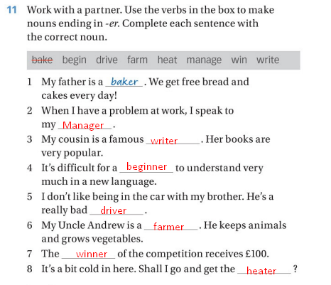
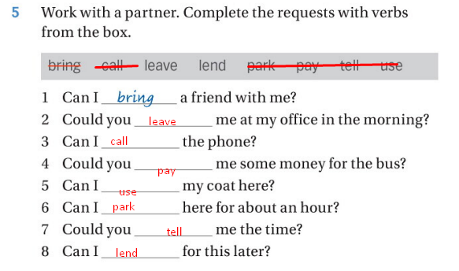

18 – oktyabr 2024

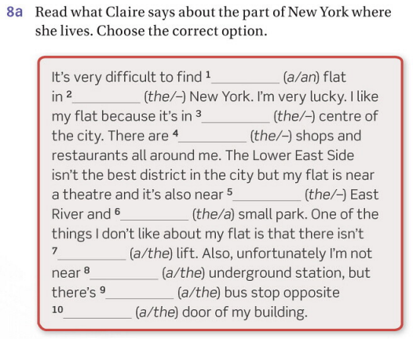
- A flat
- – new york
- The centre
- – shops
- The East River
- A small park
- A lift
- The underground
- A bus
- The door of my building

Home work 4.1, 4.2.

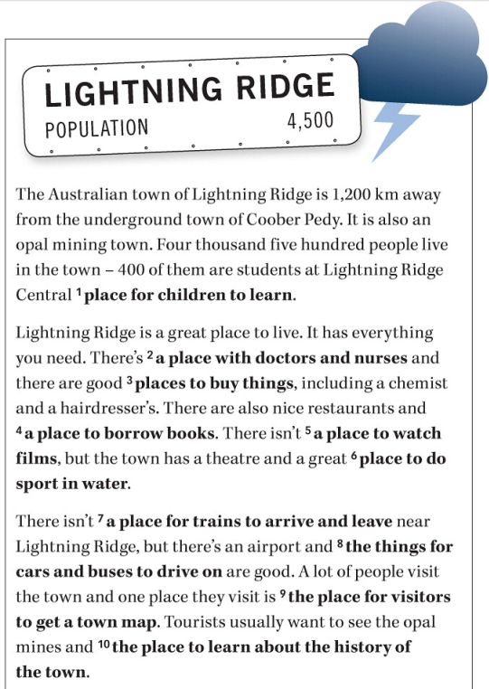

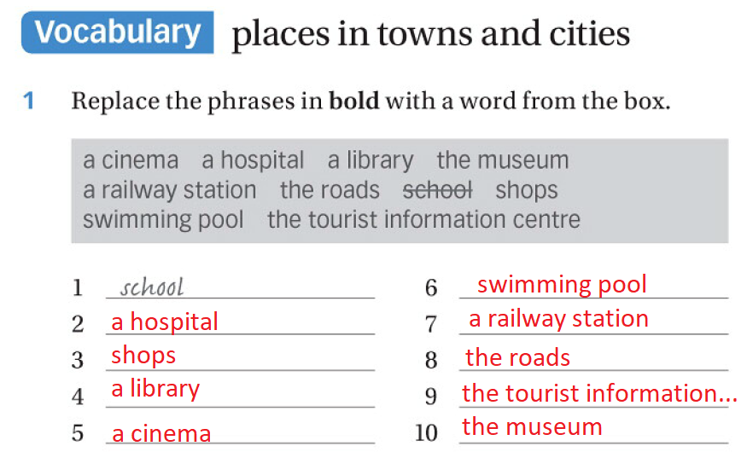

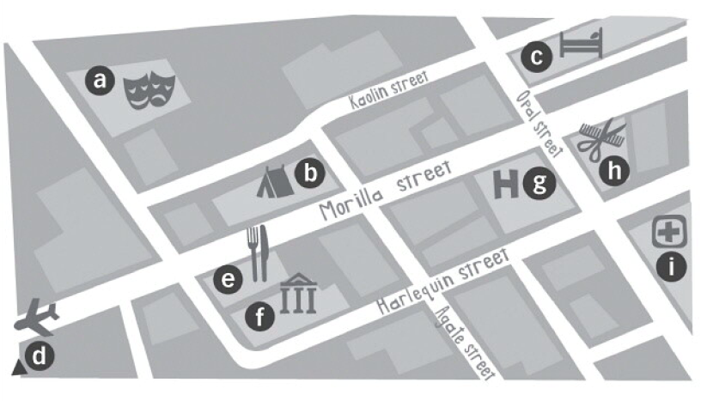
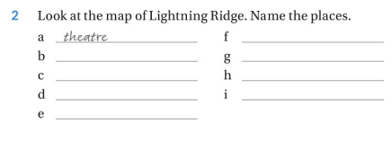
- Theatre
- Tent
- Hotel
- Airplane
- Restaurant
- Museum
- Hospital
- Haiddresser
- Medicine

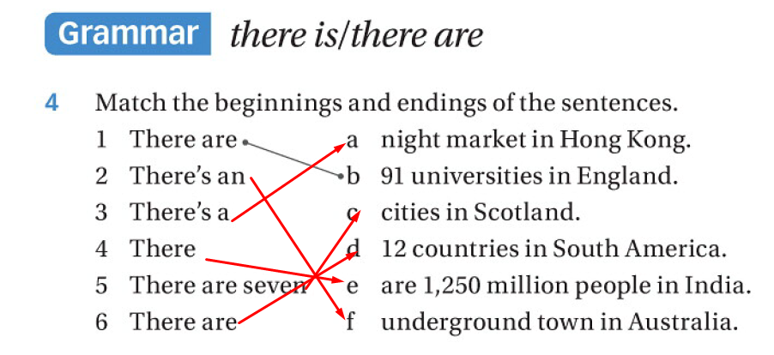

Listening

- Carefully
- Dangerously
- Quitly
- Late
- Clearly
- Correctly
- well

3a
- E - True
- I – False F
- F – False H
- A - True
- B - True
- C - True
- H – False I
- G - True
- D – True

Homework
part 1 questions topic 3
workbook 5.3 and 5.4

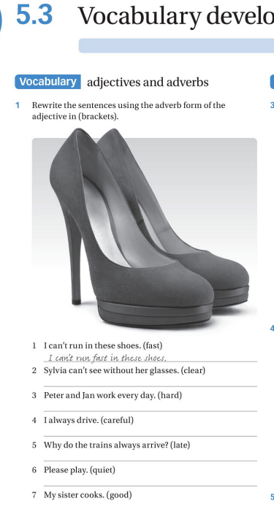

2. Sylvia can’t see clearly without her glasses
3. Peter and Jan work hard every day.
4. I always drive carefully.
5. Please play quietly
- Why do the trains always arrive lately.
- My sister cooks well.

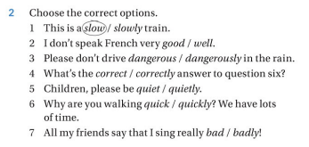

      - Slow
      - Well
      - Dangerously
      - Correctly
      - Quiet
      - Quickly
      - Bad

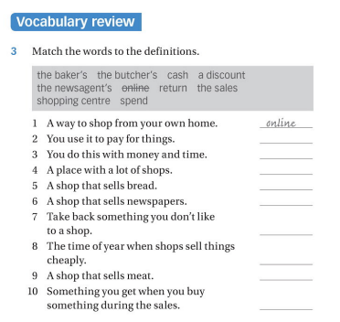
A way to shop from your own home – online
You use it to pay for things – cash
You do this with money and time – spend
A place with a lot of shops – shopping centre
A shop that sells bread – the baker's
A shop that sells newspapers – the newsagent’s
Take back something you don’t like to a shop – return
The time of year when shops sell things cheaply – the sales
A shop that sells meat – the butcher’s
Something you get when you buy something during the sales – a discount

Clothes | Accessories
coat | glasses
dress | gloves
hat | jewellery
hoodie | tie
jacket | umbrella
jeans
scarf
shoes
skirt
socks
suit
T-shirt
top
trainers
trousers

30. 10 . 2024
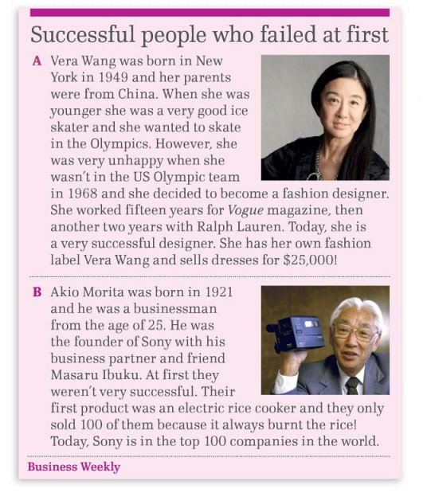
 | Vera Wang | Akio Morita
Born (when?) | She was born in 1949
Early career | She was a very good Ice skater
Problems | Shes problem were unhappy, because of she wasn’t in the US Olympic team
Famous for… (what?) | She became designer, she worked fifteen years for Vogue magazine, then another two years with Ralph Lauren.

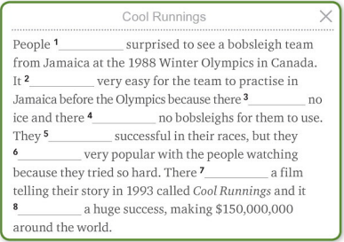

- Was T
- Was F (Was not)
- Was T
- Were T
- Were not T
- Were T
- Was T
- was T

6.1
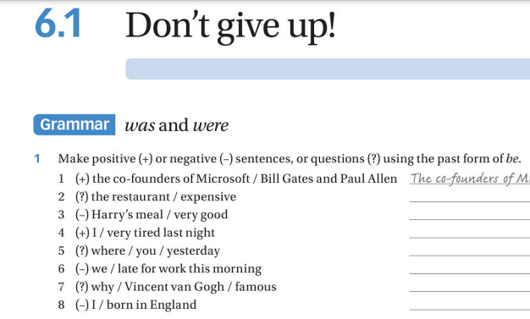

- was the restaurant an expensive?
- Harry’s meal wasn’t very good
- I was very tired last night
- Where was you at yesterday
- We were not late for work this morning
- Why Vincent van Gogh was famous?
- I was not born in England

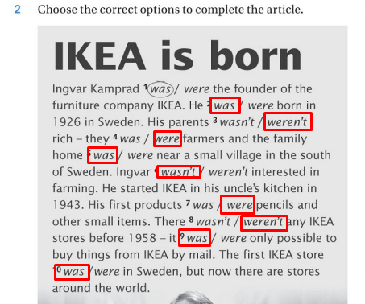

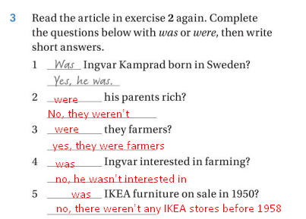
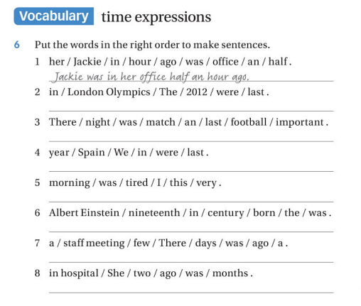
- Jackie was in her office half an hour ago
- The London Olympics were in 2012 last
- There football match was an important last night
- We in span were last year
- I was tired in this morning
- Albert einstein was born in the century nineteenth
- There a staff meeting was a few days ago
- She was in hospital two months ago

+5

Ok
I don’t think it’s fashionable

6.2
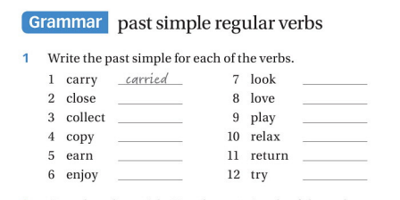

- Carried
- Closed
- Collected
- Copyed
- Earned
- Enjoyed
- Looked
- Loved
- Played
- Relaxed
- Returned
- Tried

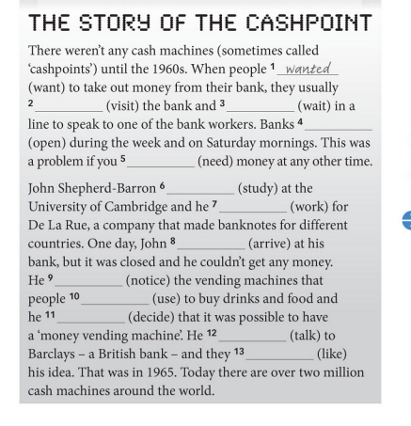
- Wanted
- Visited
- Waited
- Opened
- Needed
- Studied
- Worked
- Arrived
- Noticed
- Used
- Decided
- Talked
- Liked

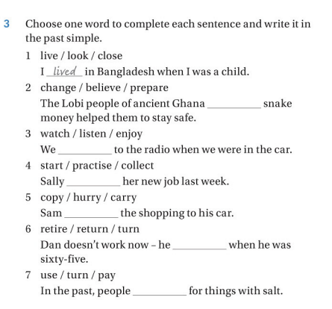

- Lived
- Prepared
- Listened
- Started
- Carried
- Retired
- Used

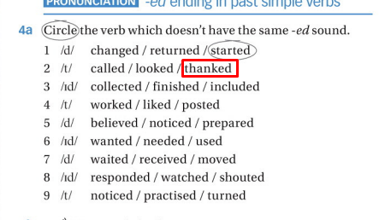
I don’t understand

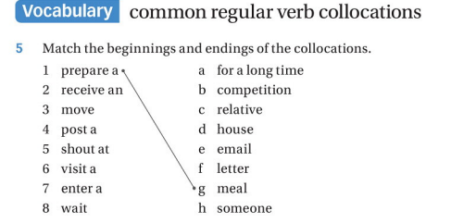

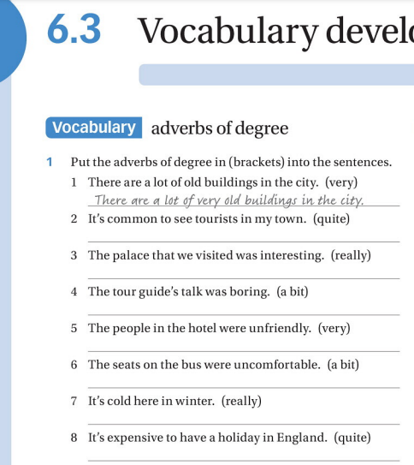
- Done!
- It’s common quite to see…
- The palace that we visited was really interesting
- The tour gude’s talk was a bit boring
- The people in the hotel were very unfriendly
- … were a bit uncomfortable
- It’s really cold in winter
- It’s quite expensive to have holiday in England

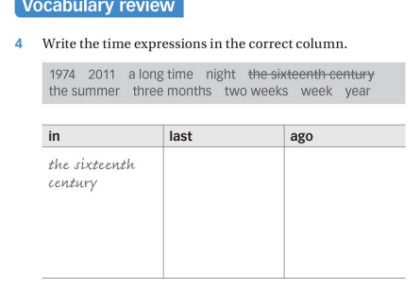
in | last | ago
The sixteenth | night | A long time
century | week | Three months
1974 | year | Two weeks
2011
The summer

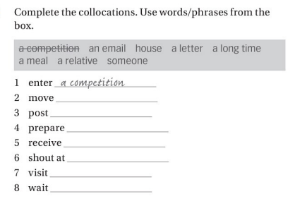

- Done!
- House
- A letter
- A meal
- An email
- Someone
- A relative
- A long time

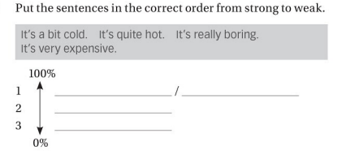
- It’s very expensive / it’s really boring
- It’s quite hot
- It’s a bit cold

- Died
- Was
- Decided
- Loved F - love
- Payed
- Wanted
- Was
- Painted
- Was F - is
- Traveled F – travel

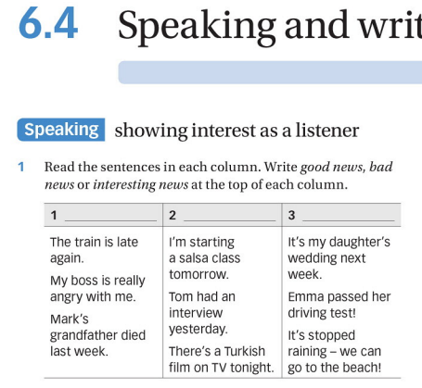

- Bad news
- Interesting news
- Good news

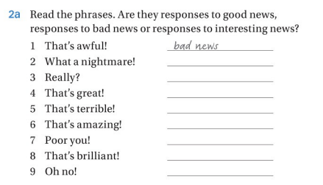
- Done!
- Bad news
- Interesting news
- Good news
- Bad news
- Good news
- Bad news
- Interesting news
- Bad news

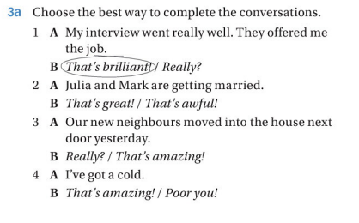
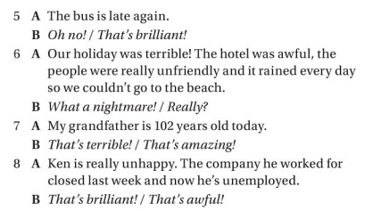
- Done!
- That’s great
- Really?
- Poor you!
- Oh no
- What a nightmare
- That’s amazing
- That’s awful

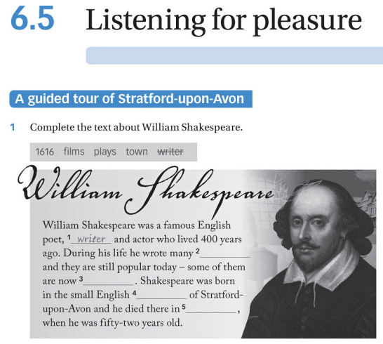
- Done!
- Films
- Plays
- Town
- 1616
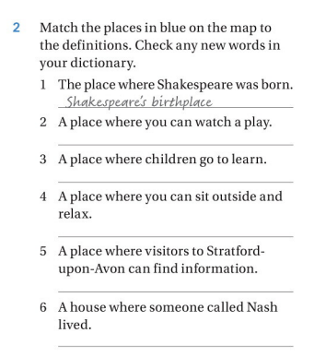
I don’t understand

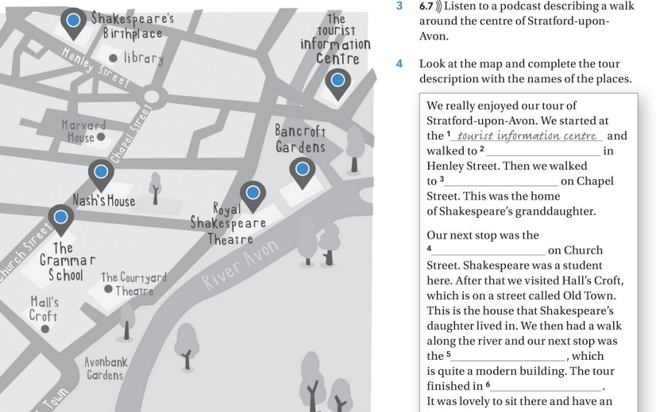
- Done
- Shakespeare’s
- Nash’s home
- The grammar school
- Royal shakerpeare theatre
- Bardencoft gardens

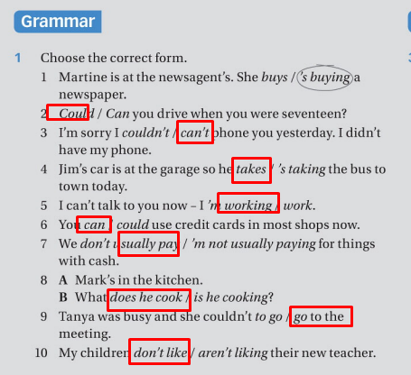

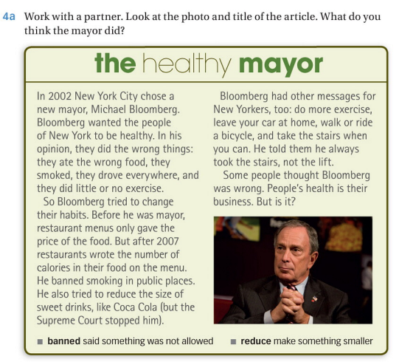
- Ate the wrong food, smoked, drove everywhere, little or no exercise
- Wrote the number of calories in their food on menu, he banned smoking
- Tried to reduce the size of sweet drinks
- Do more exercise
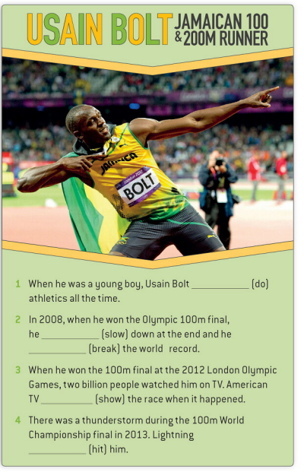
- Did F (Didn’t do)
- Slow F (slowed)
- brouk
- Showed
- Didn’t

- D
- A
- E
- B
- C

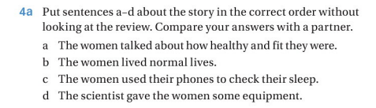

- D
- B
- C
- A

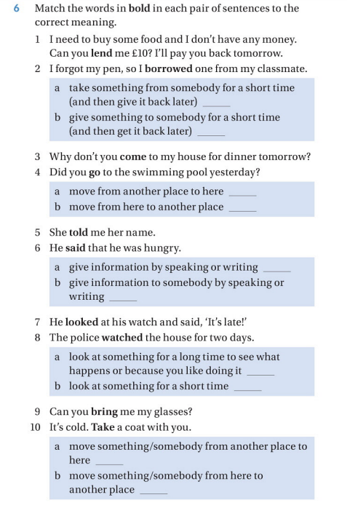
- B
- A
- A
- B
- A F
- B F
- B
- A
- A
- B

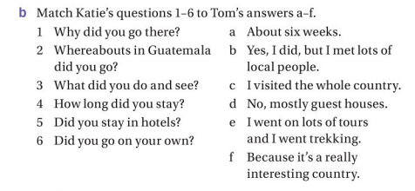

- F
- c
- E
- A
- B F (D)
- D F (B)

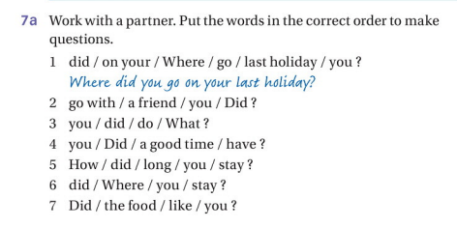
- Done!
- Did you go with a friend?
- What did you do?
- Did you have a good time?
- How long did you stay?
- Where did you stay?
- Did you like the food?

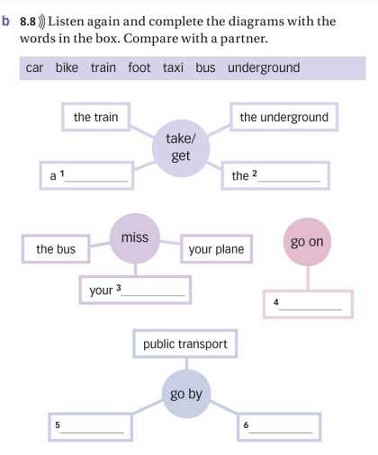
- Car F
- Bike F
- Train
- foot
- underground F
- bus F

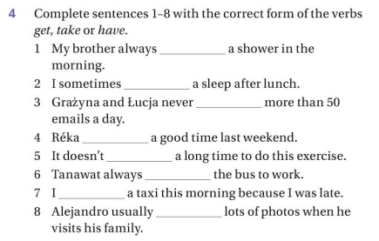
- have F has/takes
- get F have
- get
- had
- took F take
- take F takes/gets
- got (took)
- takes

- I’m taking lots of photos, because everywhere is really colorful and interesting.
- There’s just so much to do and see, so I decided to stay here for another week.
- I got lost, because I forgot my map.
- We stayed in the hotel because .
- We went to the beach because we love swimming.
- The food was really good so we ate at a local restaurant.

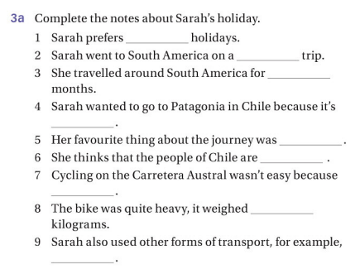

- ?
- Cyling trip
- ?
- Different content()
- ?
- ?
- ?
- 47
- Bus,
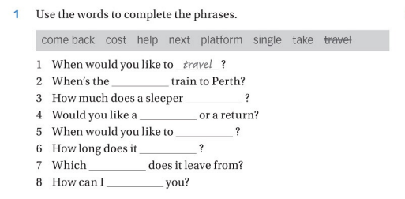
- Done!
- Next
- Cost
- Single
- Come back
- Take
- platform
- help

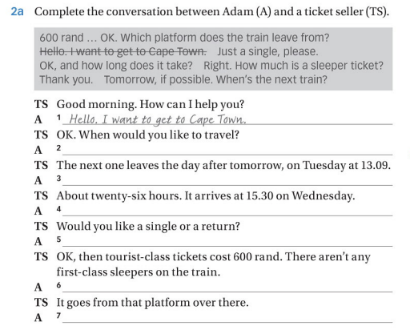

- Done!
- Tomorrow, if possible. When’s the next train?
- OK, and how long does it take?
- Just a single, please.
- Right. How much is a sleeper ticket?
- Thank you.
- Which platform does the train leave from?
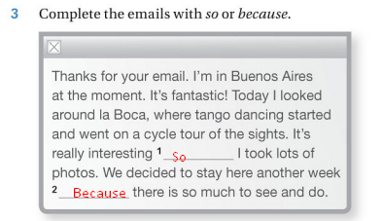
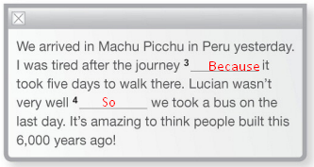

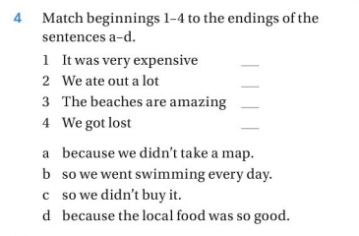
- C
- D
- B
- A
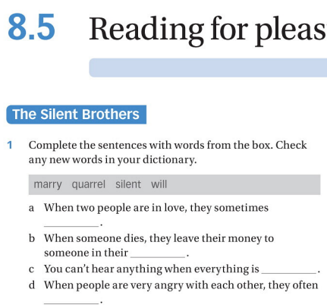

- Marry
- Quarrel
- Silent
- Will

2.
They angry, they maybe like each other but they got a problem

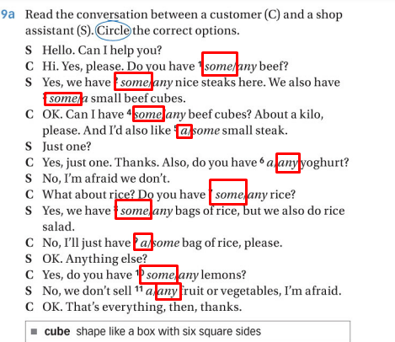
- F
- T
- T
- T
- T
- T
- F
- T
- T
- F
- T

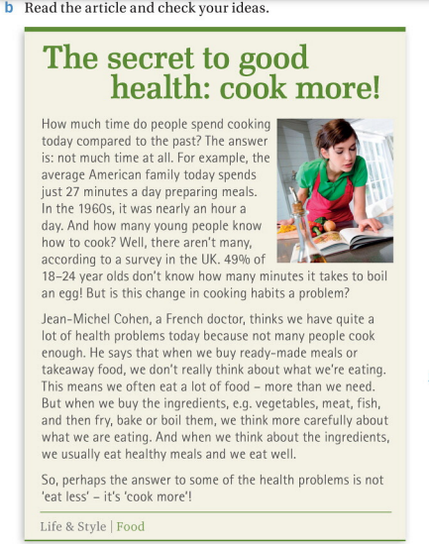
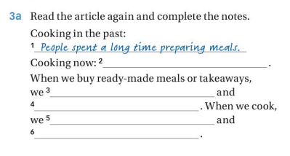
- Done!
- Not many peoples cook enough F
- We don’t really think about what we’re eating.
- And we often eat o lot of food more than we need
- we usually eat healthy meals
- and we rat well

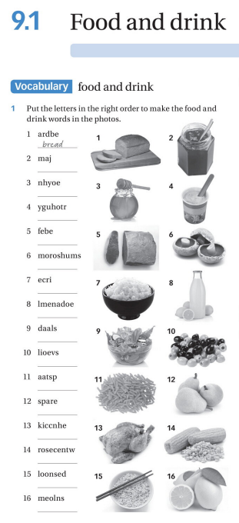

- bread
- jam
- honey
- yoghurt
- beef
- moshrums
- rice
- lemonade
- dalas
- olivies
- pasat? (salat)
- Pears
- Kichen
- Corn?
- dolones?
- Lemons

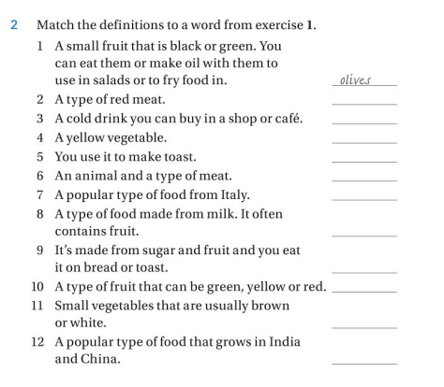
- Done!
- Beef
- Soda
- Corn
- Butter
- Chicken
- Pizza
- Cheese
- Jam
- Apple
- Muchrooms
- Rice

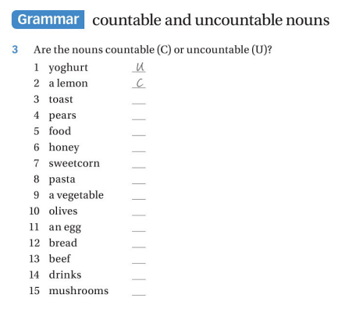
- U
- C
- C
- C
- U
- U
- C
- U
- C
- C
- C
- C
- U
- U
- C
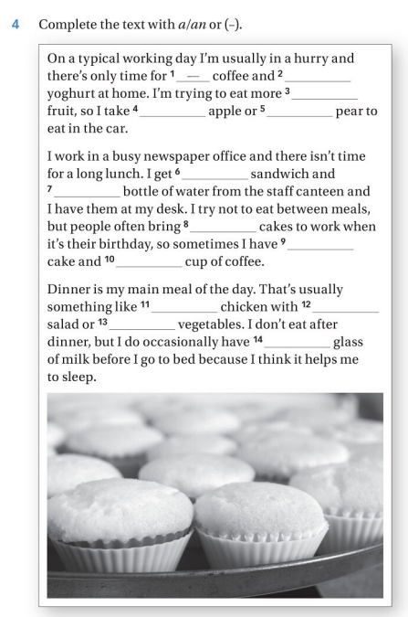

- Done!
- ---
- -
- an
- a
- a
- a
- -
- - (some)
- A
- -
- A
- - (some)
- A
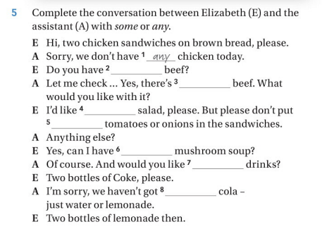
- any
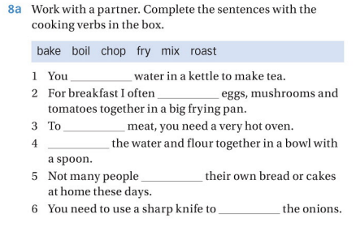
- boil
- fry
- roast
- bake F
- mix F
- chop
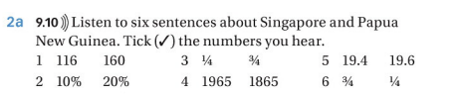
- . (160)
- 10%
- ¾
- (1965)
- (19.4)
- ¼

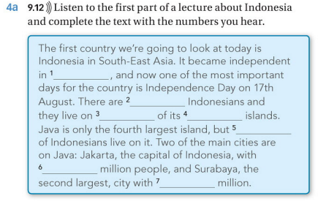
- 1945
- 340 (240mln)
- 80 (F)
- ?
- 80% (60%)
- 8.6mln (8.6mln)
- 2.7 mln
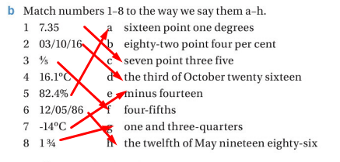
4 – A

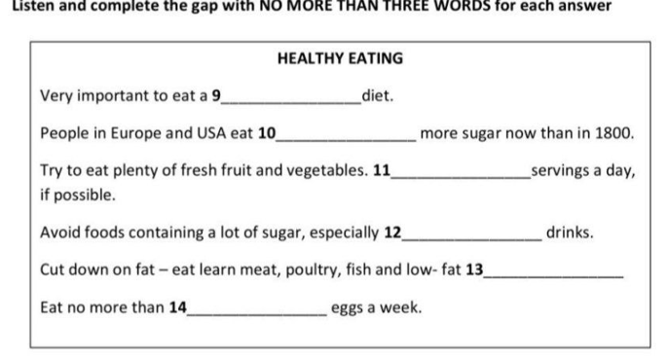
- Fresh food
- .
- five
- corbonite
- .
- Four

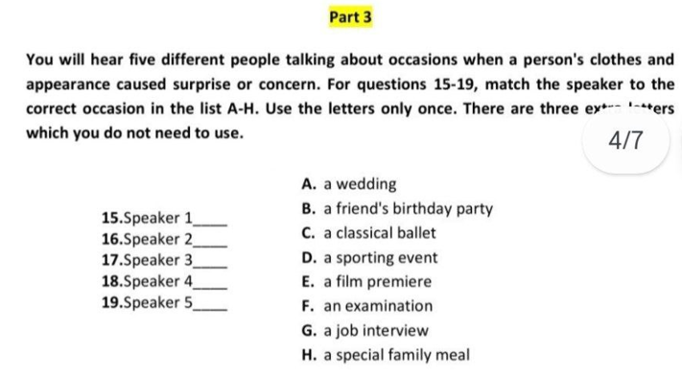
- b
- f
- e
- d

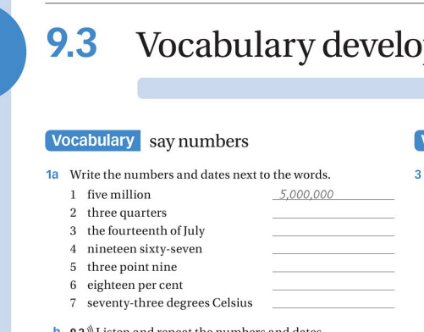
- Done!
- ¾
- 14.july
- 1967
- 18.0
- 73%

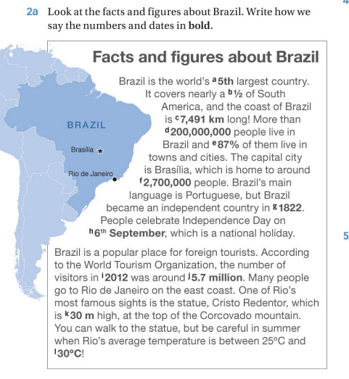
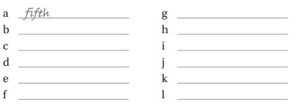
- Fifth
- One half
- Seven thausan four hundered ninety one
- Two hundered million
- Eighty seven celcius
- 2 hundered 7 thousand million
- Eighteen twenty two
- Sixth September
- Twenty 12 ?
- Five point seven million
- Threty meter
- Threty degres

  - from English Grammer in use book

- mountain T
- coast / rainforest ?
- waterfall ? lake
- rainforest T
- river / islands / ?
- ?
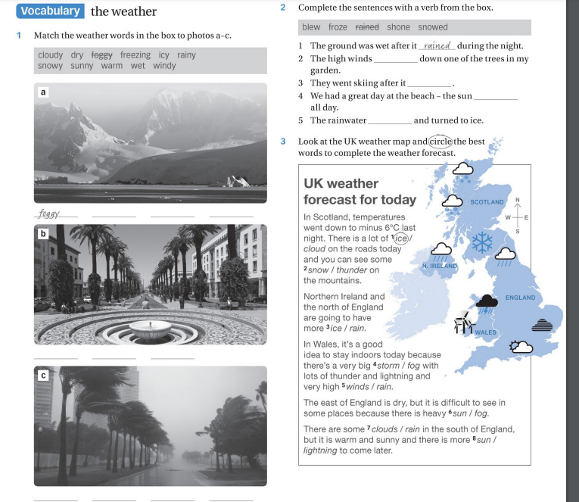

- Foggy, cloudy, dry, icy
- Wet, sunny, warm
- Windy, sowy, rainy

2.
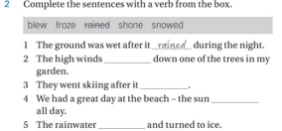
- Done!
- Blew
- Snowed
- Shone
- Froze

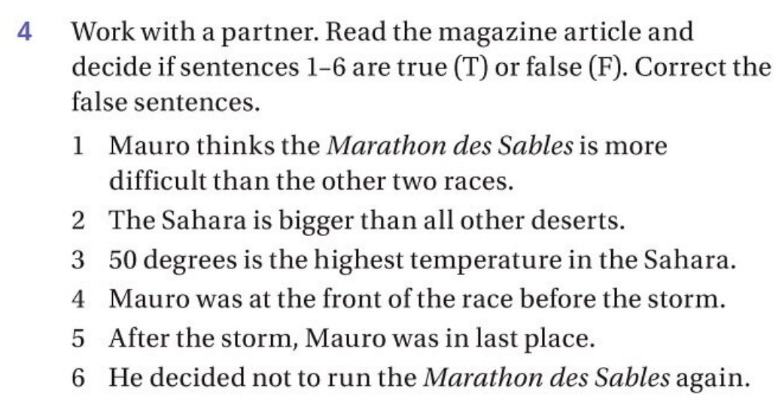
- T
- F
- F
- T
- T
- T - False (F)

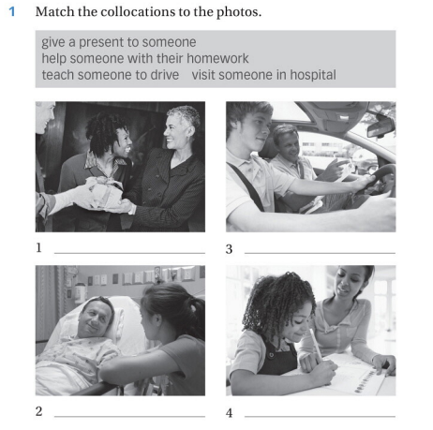
- Give a present someone
- Visit someone in hospital
- Teach someone to drive
- Help someone with their homework
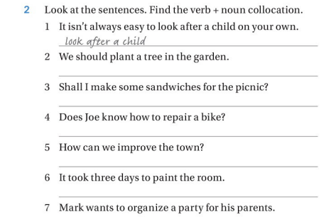
- Done!
- Plant a tree
- Make some sandwiches
- Repair a bike
- Improve the town
- Paint the room
- Organize a party
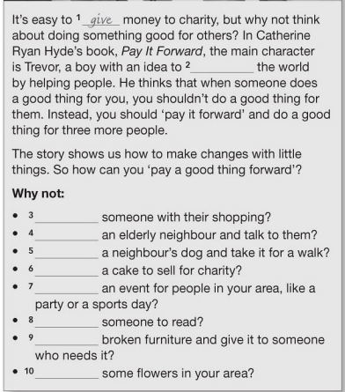
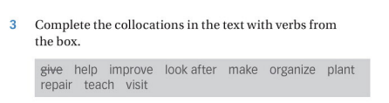
- Give
- Improve
- Help
- Visit
- Look after
- Make
- Organize
- Teach
- Repair
- Plant

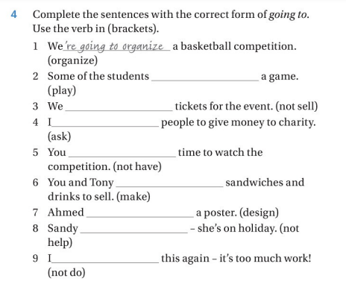
- Done!
- Are going to play
- Aren’t going to sell
- Am going to ask
- Aren’t having to ?
- Are going to make
- Is going to design
- Isn’t going to help
- Am not going to do

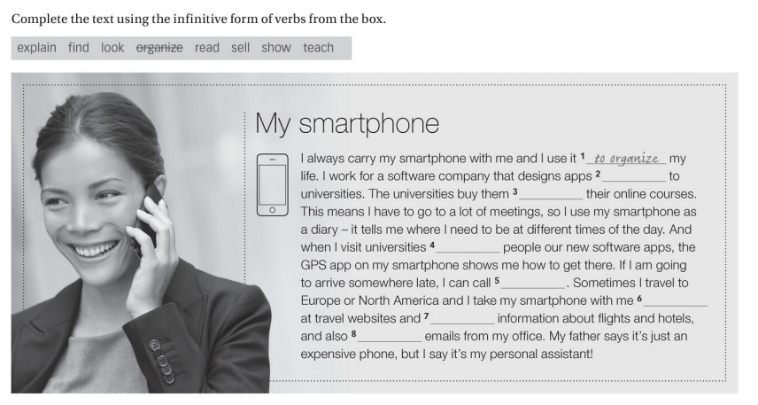
- Done!
- Selling
- to teach
- to show
- to explain
- to look
- to find
- to read
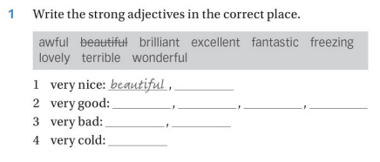
- brilliant
- fantastic, wonderful, lovely, excellent
- freezing, awful
- terrible

12.10

- I am / left (I’ve)
- went
- have / seen (left)
- have / want (wolkt out)

next ->
- 2
- 2
- 1
- 1
- 1?
- 1?
- 2?
- 1 (my choice 2) result 1
- ?
- ?
- ? 1
- ? 1
- ? 1
- ? 1

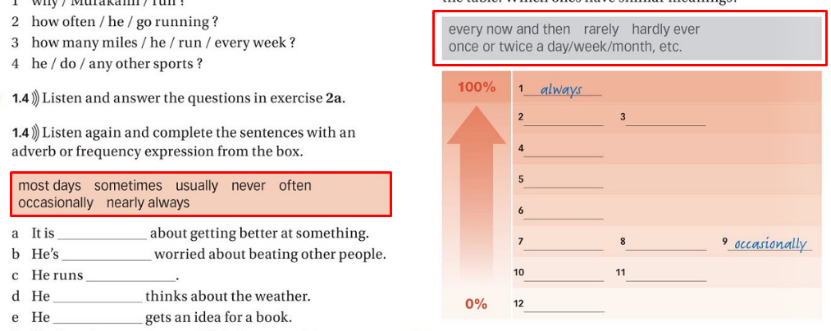
- Always
- Nearly always
- Most days
- Usually
- Often
- Sometimes
- Every now and then
- Once or twice a day/week/month
- Occosionaly
- rarely
- Hardly ever
- Never

- C
- B, C
- B
- C
- B
- C

Verbs (fe’llar) | Nouns (Otlar) | Translation
Rise | A rise | Ko’tarilmoq
Incerease | An increase | O’smoq
Peak | A peak | Eng cho’qqisi
Fall | A fall | Yeqilmoq tushmoq
Decrease | A decrease | Tushmoq, Tushish
Decline | A decline | Tushmoq
Go down | N/A | Tushmoq
Remain stable | (a period of stability) | O’zgarishsiz qolmoq, o’zgarmaslik
Remain steady | N/A | O’zgarishsiz qolmoq
Fluctuate | A fluctuation | O’sib tushmoq, ne stablniy

Adverb (ravish) | Adjective (sifat) | Uzbek Translation
Dramatically | Dramatic | Juda kuchli tarzda / Jiddiy — Jiddiy, keskin
Sharply | Sharp | Keskin tarzda — Keskin
Enormously | Enormous | Juda katta darajada — Juda katta
Considerably | Considerable | Ancha-muncha darajada — Sezilarli
Rapidly | Rapid | Tezlik bilan — Juda tez
Moderately | Moderate | O‘rtacha darajada — O‘rtacha
Gradually | Gradual | Bosqichma-bosqich — Asta-sekin
Slightly | Slight | Ozgina, biroz — Ozgina

The line graph shows the number of tourists who visited the UK, France, and Italy between 2000 and 2010. The numbers are given in millions.
Overall, the number of tourists visiting all three countries increased steadily over the 10-year period. France had the highest number of tourists in every year, while Italy had the lowest.
In 2000, about 25 million people visited France. This number rose each year and reached 50 million by 2010. The UK started with 20 million tourists in 2000, and this number grew steadily to about 47 million in 2010.
Italy had the fewest visitors at the beginning, with only 15 million in 2000. However, it also saw growth and finished with around 38 million tourists in 2010.
In conclusion, tourism increased in all three countries, with France remaining the most popular destination, followed by the UK and Italy.

How many – a number of
Now much – an amount of

The line graph illustrates a number of

